Earth Science Lab Syllabus
Earth science lab will help you understand what is discussed in class. You will have a more hands-on approach in lab as compared to class. You need 1200 minutes of passing lab time in order to take the regents exam in June. I will send a list of completed labs with the lab time home with report cards at the end of each quarter.

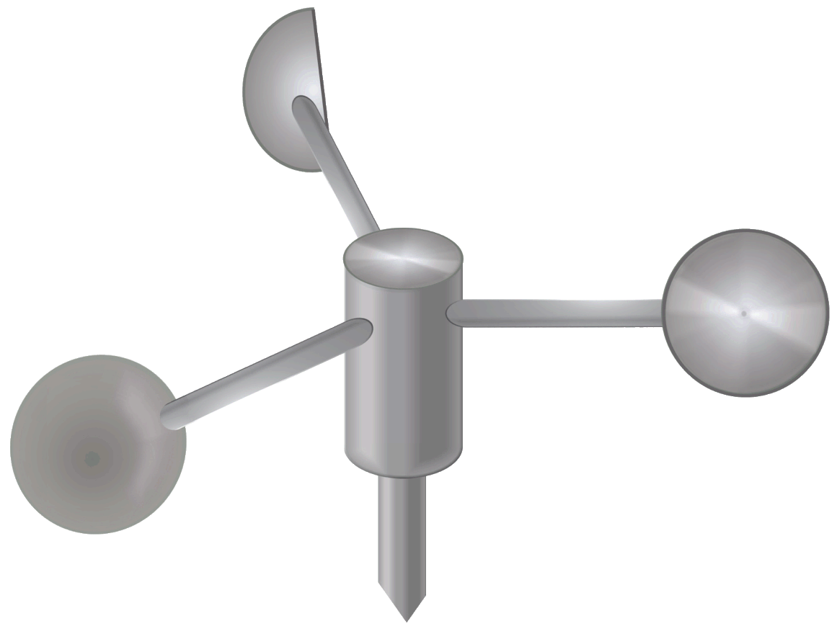

Lab Information

Write-up
You and your partner are responsible for getting the information needed for the lab write-up. This does not mean you will have the same write up as each other. You need to use your own words when answering the questions. If you copy from someone and do have the same exact write-up you and the other person will not get credit for the lab. This means it does not count towards the 1200 minutes.

Labs are due when you finish them. You will have 2 lab days to work on a lab and that is usually plenty of time. If you get behind on labs, you will not be able to finish them all before the end of the marking period.

Labs
Graphing
Safety
Equipment
Circumference
Density
Minerals
Rocks
Topographic Maps
Rivers
Porosity/PermeabilityEarthquakes
Plate Tectonics
Earth’s Motions
Ellipses
The Moon
Sun’s Path
Stars
Weather
Absorption
Fossils
Radioactivity

Mrs. Jordan
Earth Science Lab
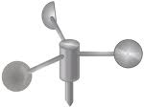
Earth Science Lab Syllabus (con’t)
Lab safety must be followed at all times in lab. You will be working with glass, hot water, etc. so everyone must be careful. If you are not being safe during lab, you may not have the chance to finish the lab you had started (this will reflect in your grade).
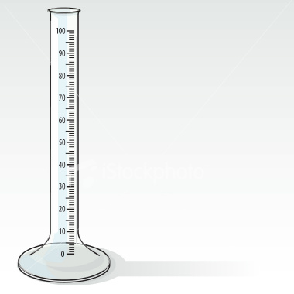short title for your newsletter— something like "School News," or “Back to School.” As you choose the title, also take time to think about the newsletter’s theme. What important messages do you want to send parents and families?
Next, establish how much time and money you can spend on your newsletter. These factors will help determine how frequently you publish the newsletter and its length.
Use the body of your school newsletter to keep parents apprised of major assignments and class events, as well as of any school district news.

Lab Safety

Grading
“Technology does not drive change -- it enables change.”
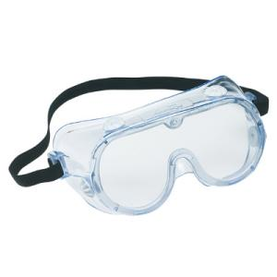.
Page 2 of 2 Earth Science lab Syllabus (con’t)

Student Signature: ______________________________

If you fail a lab you must correct it in order for it to count towards the 1200 minutes. If you do not correct it, it will not be counted as a lab for the minutes. You can only correct a lab once; if it is not passing after this one time, you can’t correct it anymore and it will not be counted towards the 1200 minutes. The corrected lab grade will only be a 65%.

Your grade at the end of a quarter includes all lab grades (passing or failing). This will then get averaged into your class grade that goes onto your report card.

All labs need to be in your folder the last week of May. This will allow us to determine if you need to do extra labs in order to take the regents.

